ServiceNow Ticket Assignment Automation

**Project Report**: Streamlining Ticket Assignment for Efficient Support Operations

# Team ID: LTVIP2026TMIDS24343

**Category:** ServiceNow

# Ideation Phase

The primary motivation behind this project is to eliminate inefficiencies in manual ticket routing processes at ABC Corporation. The manual method often leads to delayed resolutions, incorrect assignments, and underutilized support resources. The idea is to implement an automated, condition-based ticket assignment system using ServiceNow Flow Designer, minimizing delays and improving user satisfaction.

# Requirement Analysis:

* + Automate ticket routing in ServiceNow.
  + Route based on issue type.
  + Assign tickets to the right support group automatically. Requirements:
  + Create users and assign them roles.
  + Create support groups.
  + Define roles and ACL permissions.
  + Design tables with specific columns and choice values.
  + Implement logic-based flow automation.
  + Maintain secure access and role-based data access.

# Project planning phase

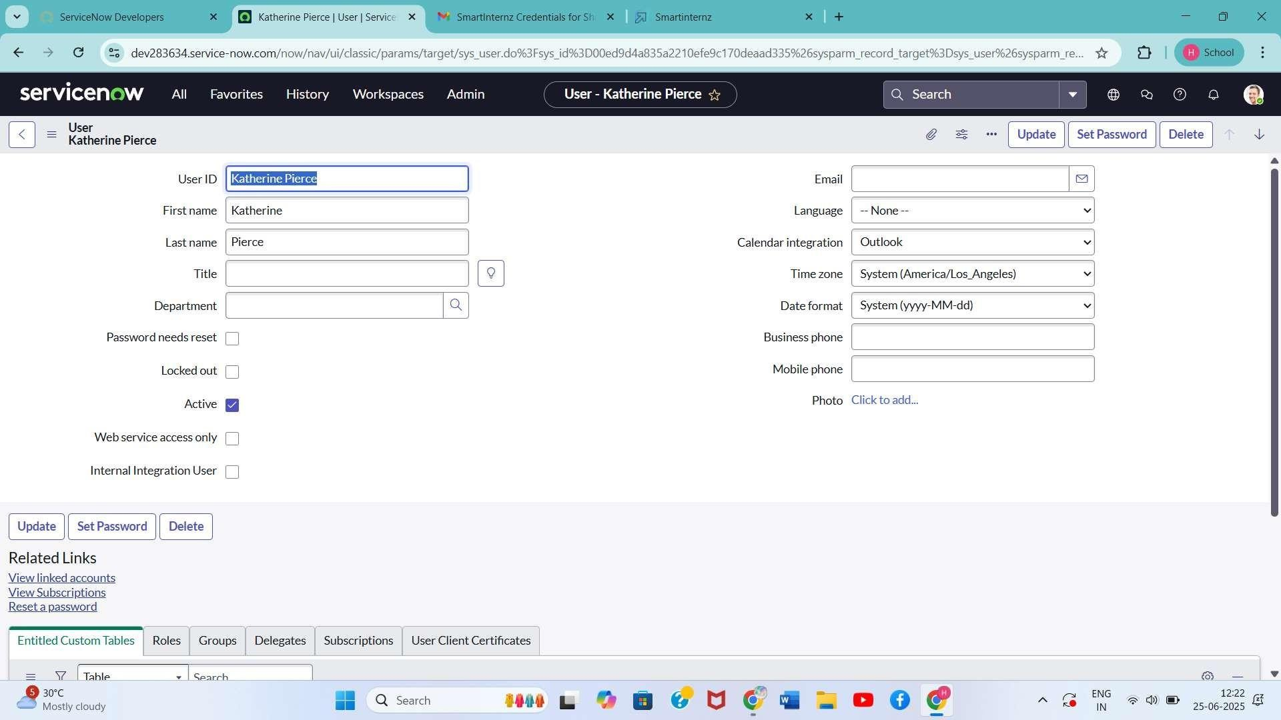

* + User & Role Management
  + Group Creation
  + Table Creation with Column Design
  + ACL Setup
  + Flow Designer Automation

# Resources Used:

* + ServiceNow Developer Instance
  + Security Admin Role
  + System User

# Project Design phase:

**User Creation**

1. Open ServiceNow.
2. Go to All > Users (System Security)
3. Click New, enter required details, click Submit.

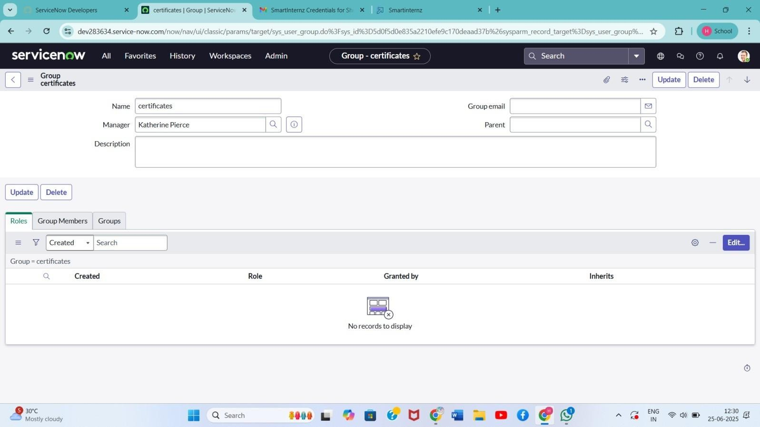

1. Repeat to create another user.

# Group Creation

1. Go to All > Groups (System Security)
2. Click New, fill details for each group (e.g., Certificates, Platform), click Submit.

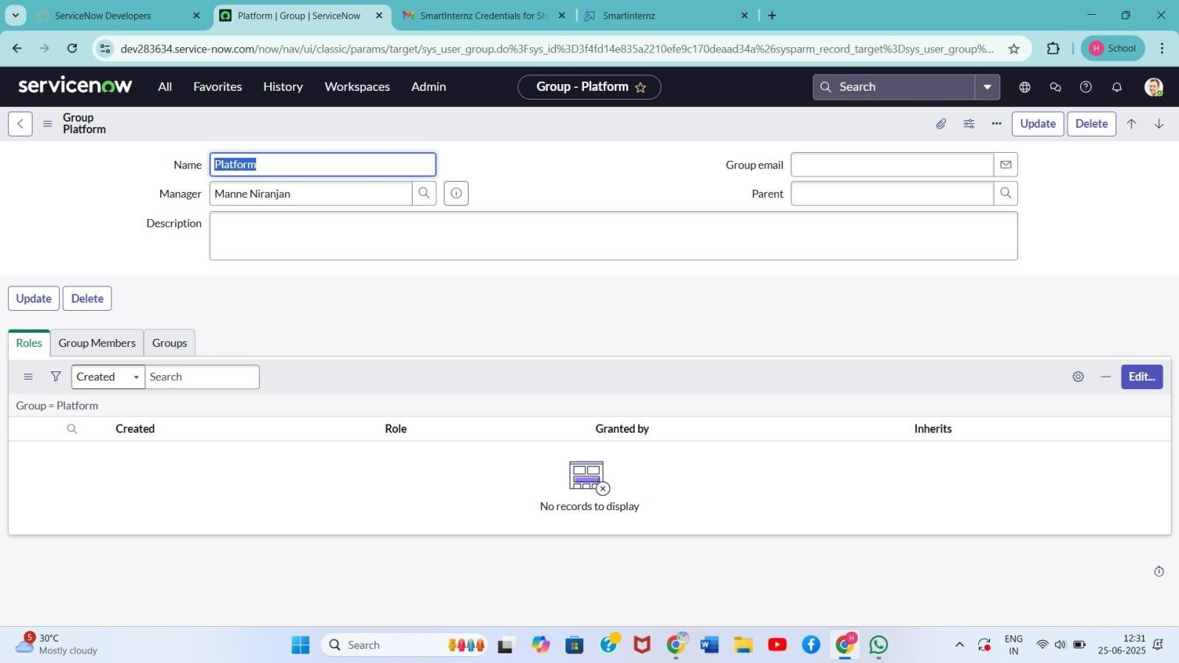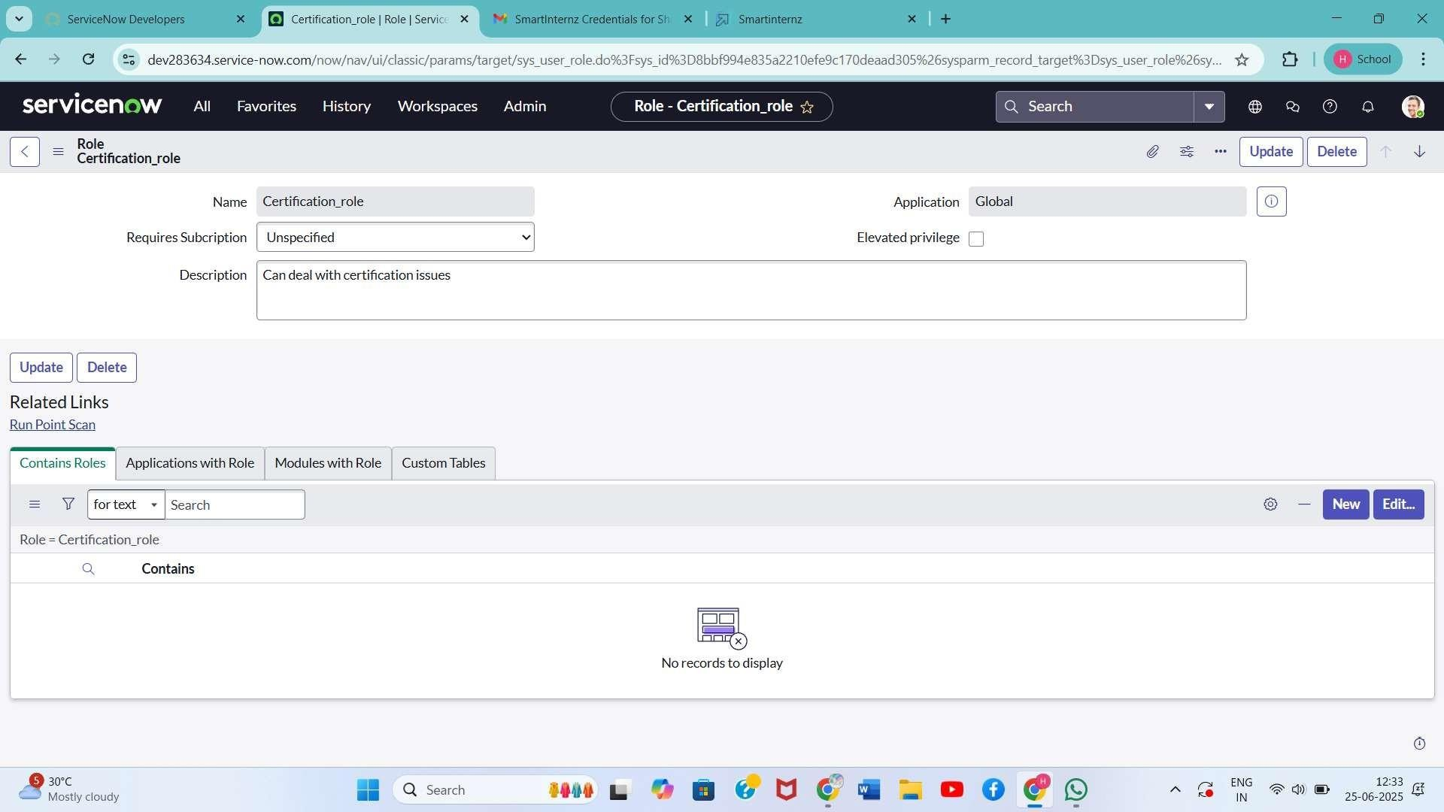

# Role Creation

1. Go to All > Roles (System Security)
2. Click New, fill details for Certification_role and Platform_role, click Submit.

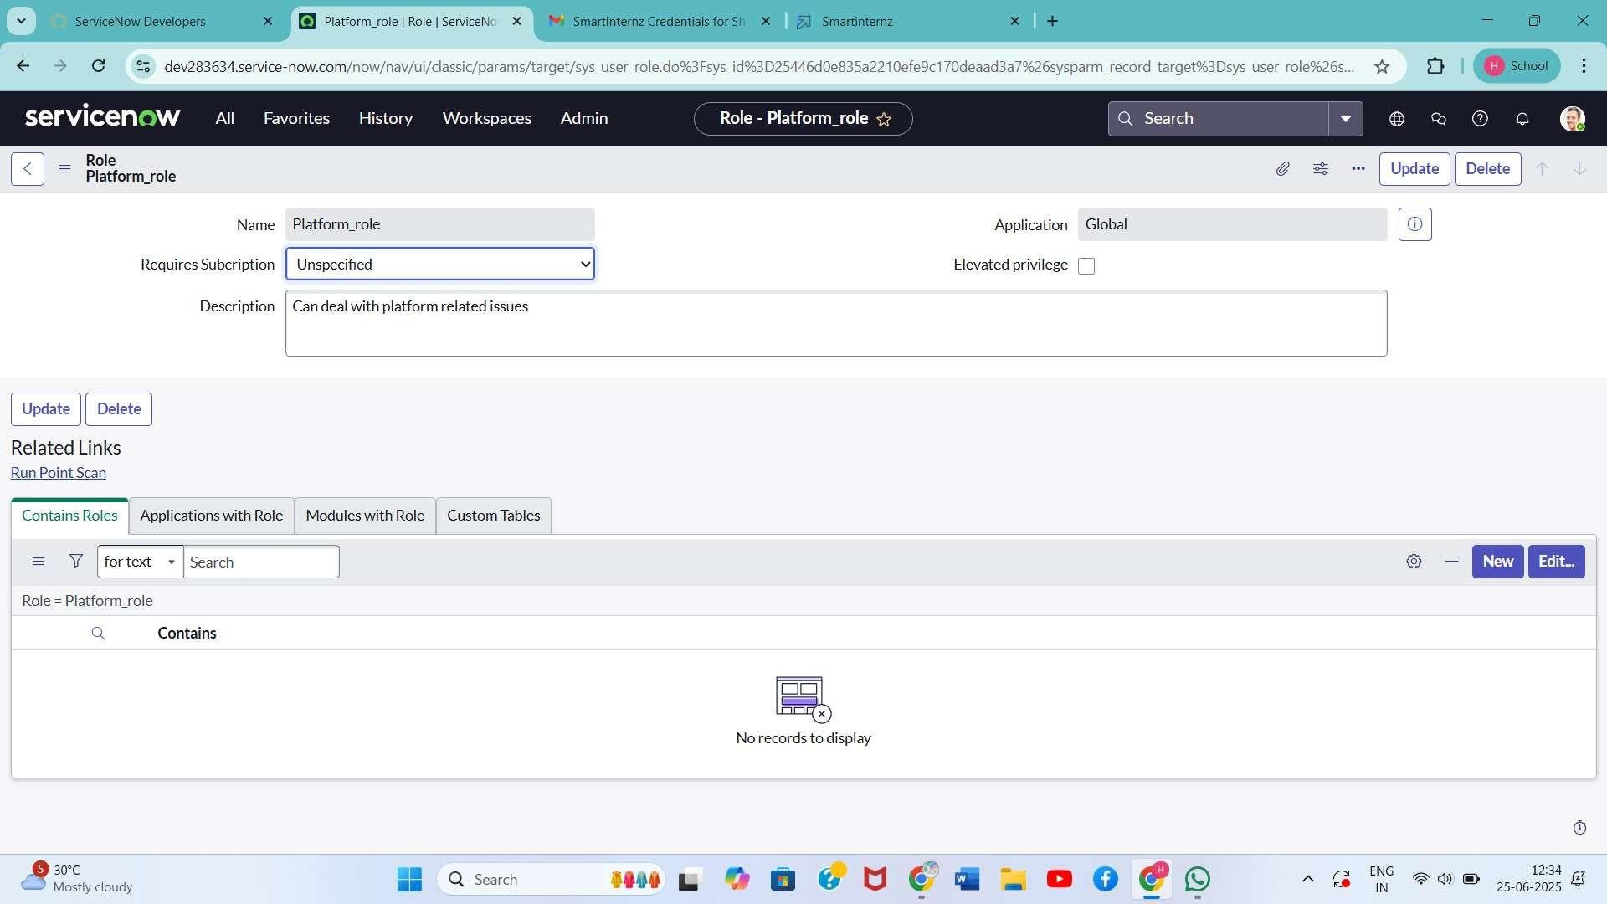

# Table Creation

1. Go to All > Tables (System Definition)
2. Create a new table:
   * Label: Operations related
   * Check: Create module & Create mobile module
   * Menu Name: Operations related
   * Add Columns:
     + issue (Choice field)
     + assigned to group
     + other required fields
3. Use Form Designer to add choices to the issue field:
   * unable to login to platform
   * 404 error
   * regarding certificates
   * regarding user expired

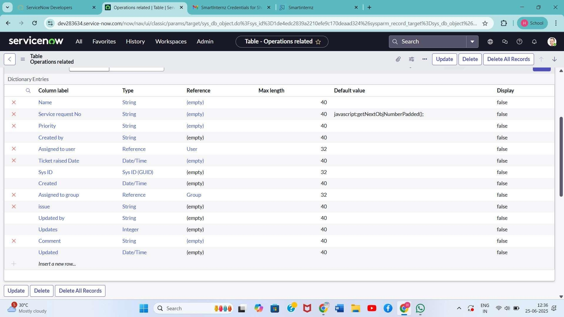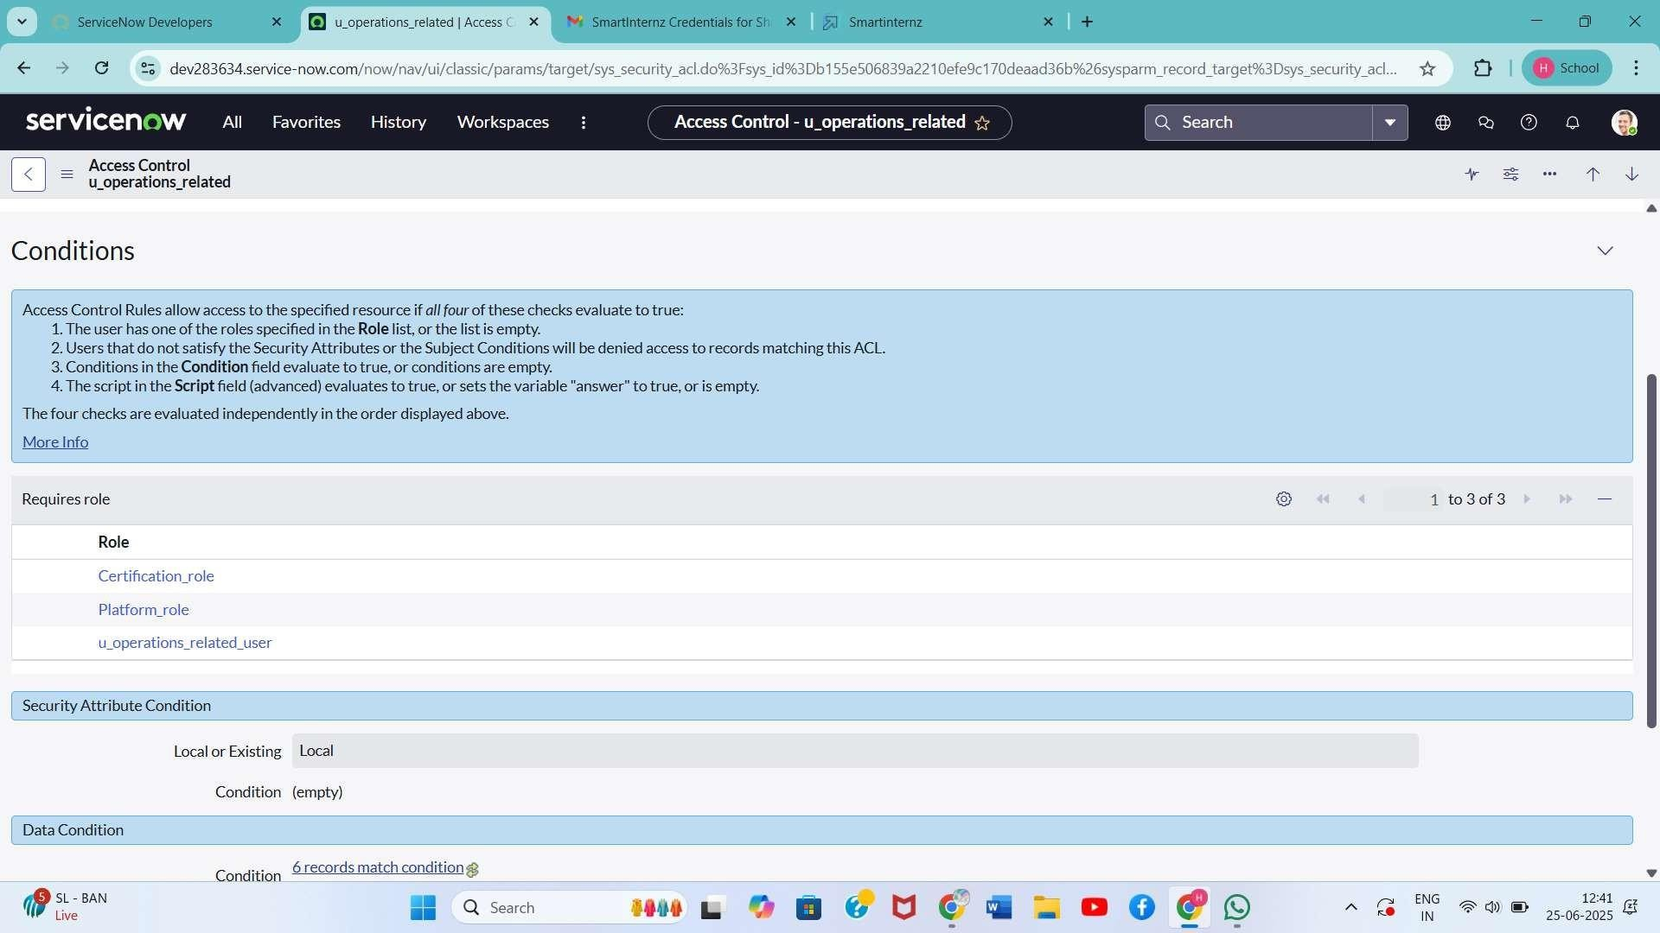

Assign Users to Groups

* + Add Katherine Pierce to Certificates group with Certification_role
  + Add Manne Nirajanan to Platform group with Platform_role

# Access Control (ACL)

1. Go to All > Access Control (ACL)

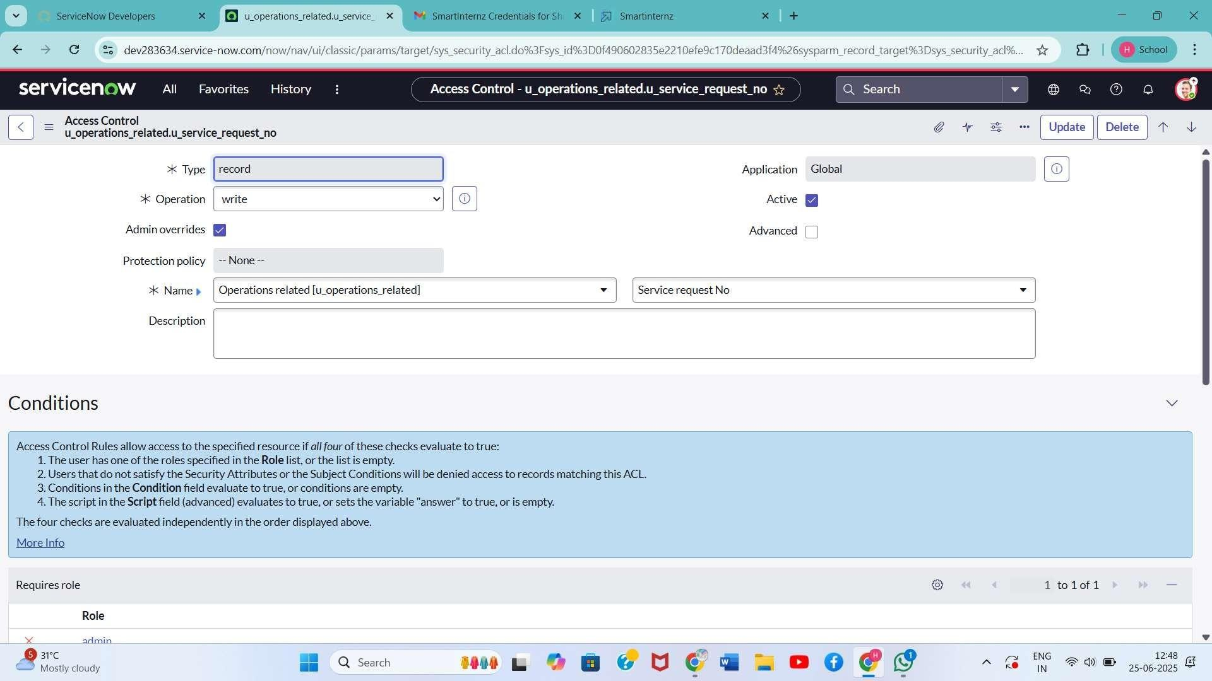

1. Create ACLs for table Operations related:
   * Read: Requires admin, Platform_role, and Certificate_role
   * Write: Requires Platform_role and Certificate_role
   * Application Access: Enable read/write access accordingly
2. Elevate role using Security Admin if needed

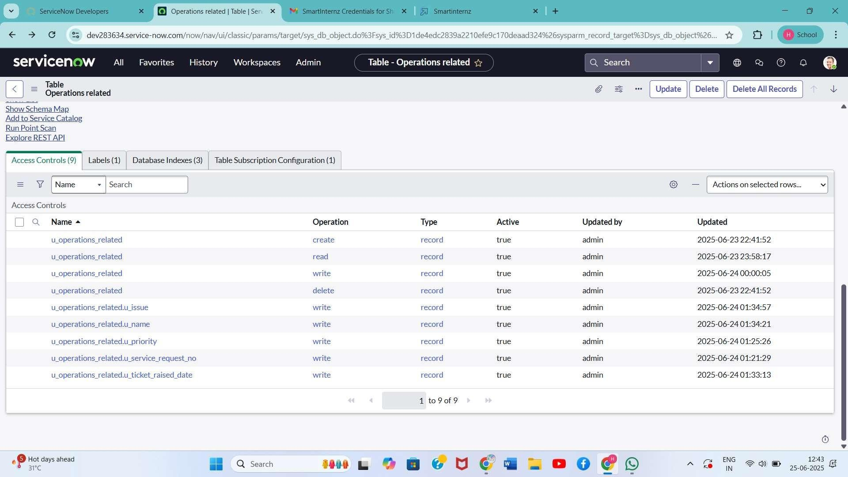

Flow Designer Regarding Certificate

1. Go to All > Flow Designer > New Flow
2. Name: Regarding Certificate
3. Application: Global, Run user: System user
4. Trigger:
   * Table: Operations related
   * Condition: issue is regarding certificates
5. Action:
   * Update Record: Assigned to group = Certificates
6. Click Save and Activate

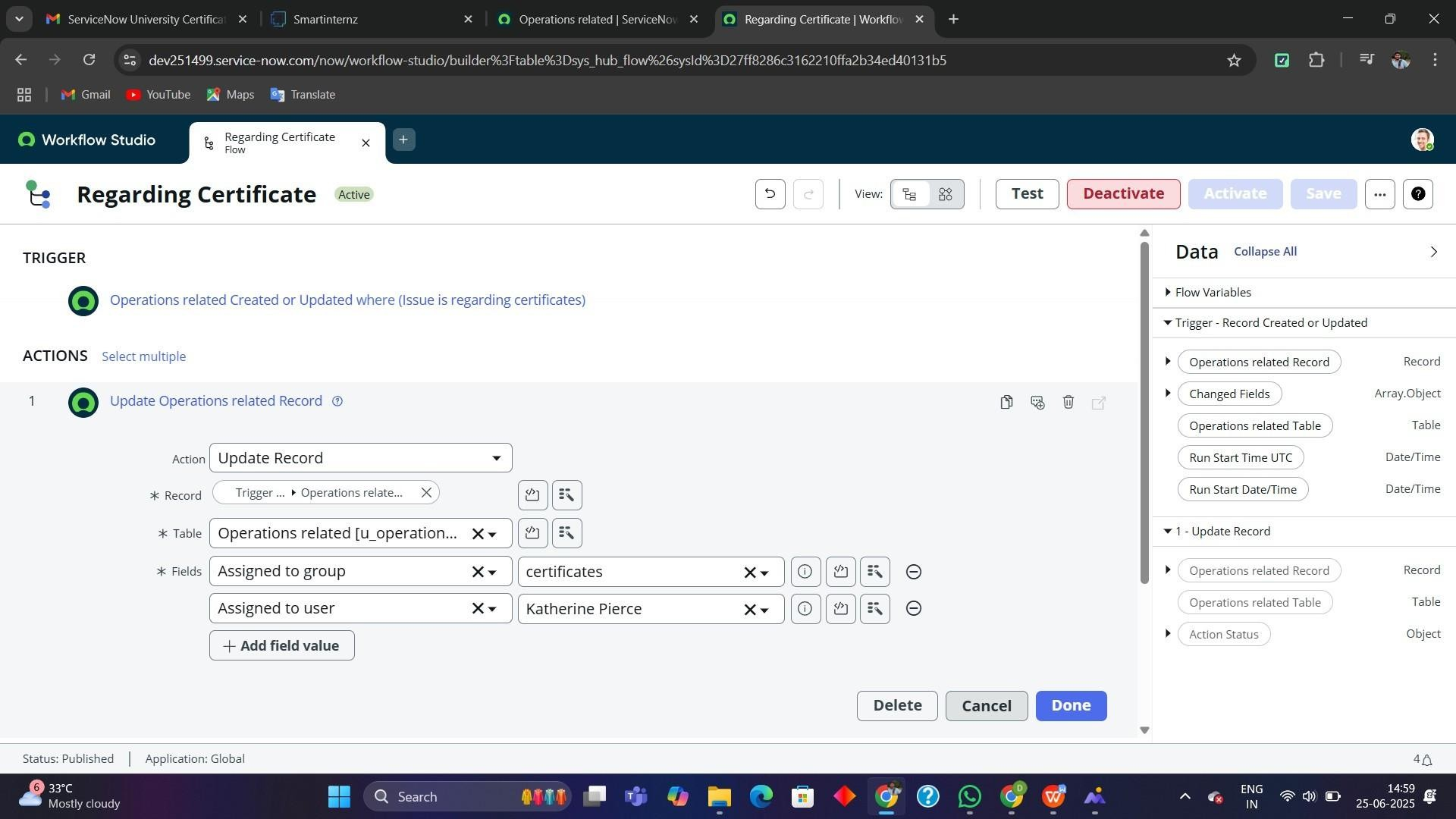

Flow Designer Regarding Platform

1. Create New Flow: Regarding Platform
2. Trigger:
   * Table: Operations related
   * Conditions:
     + issue is Unable to login to platform
     + issue is 404 Error
     + issue is Regarding user expired
3. Action:
   * Update Record: Assigned to group = Platform
4. Click Save and Activate

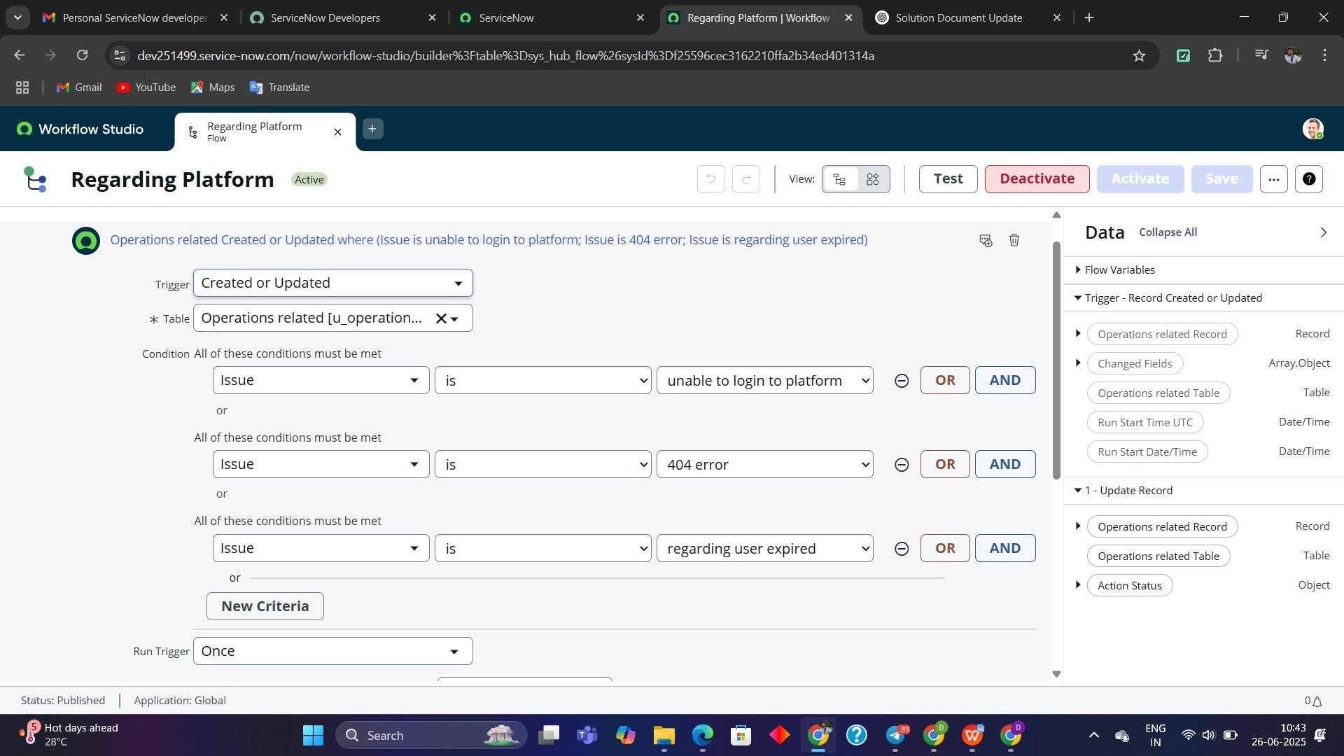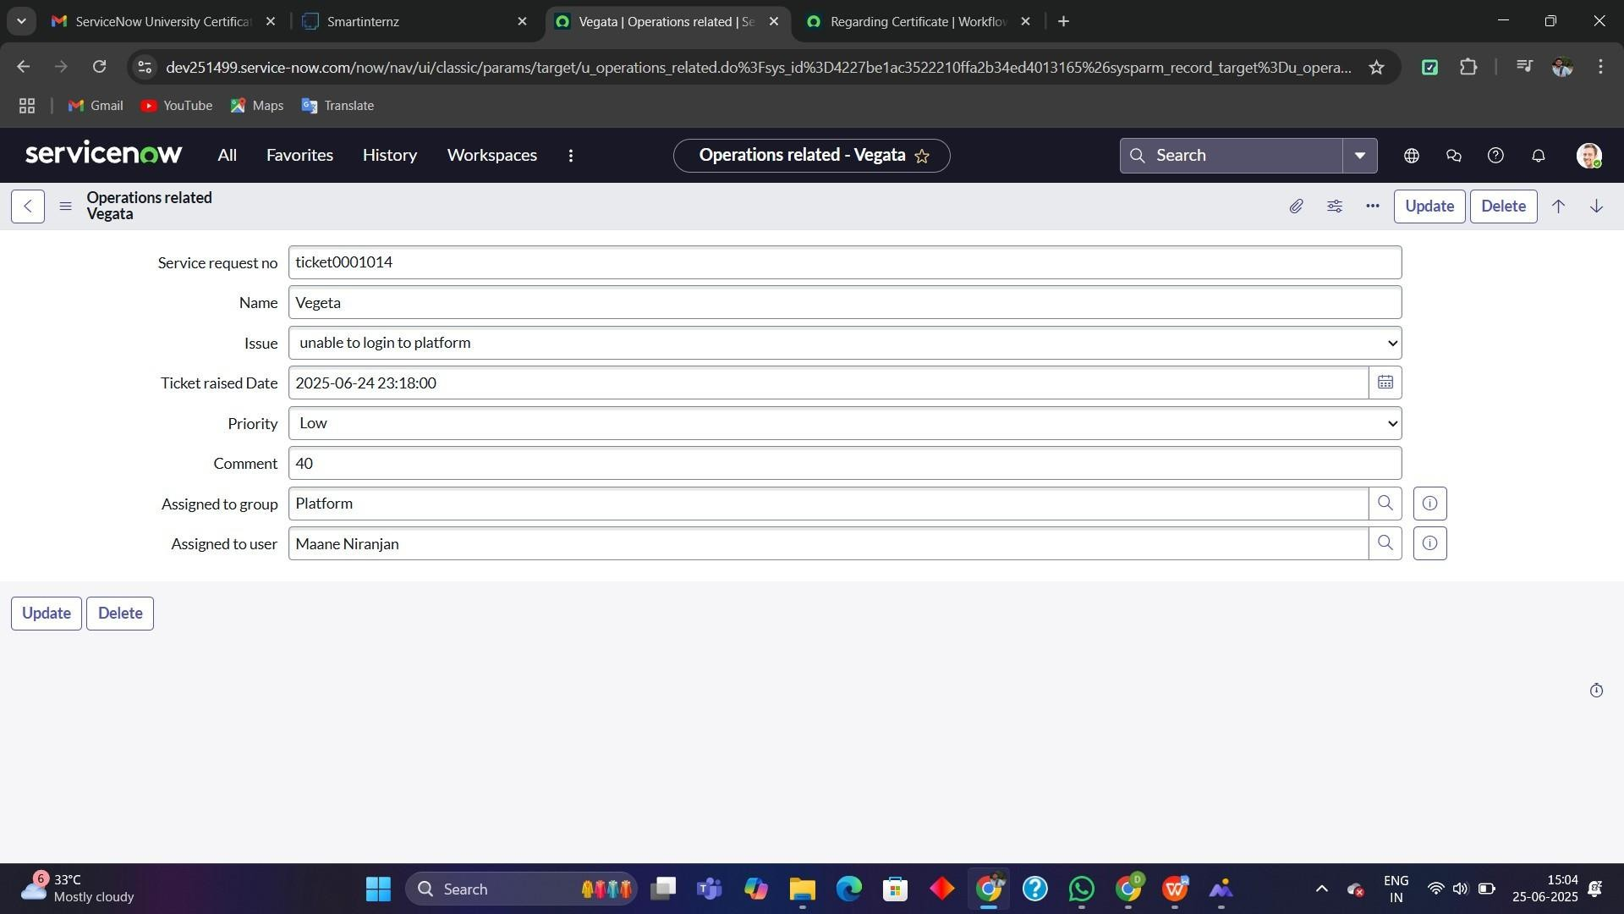

# Performance Testing:

Test Scenarios:

* + Create a record in Operations related with each issue type
  + Verify assignment is correct based on issue
  + Validate ACL enforcement by accessing table data with users in different roles

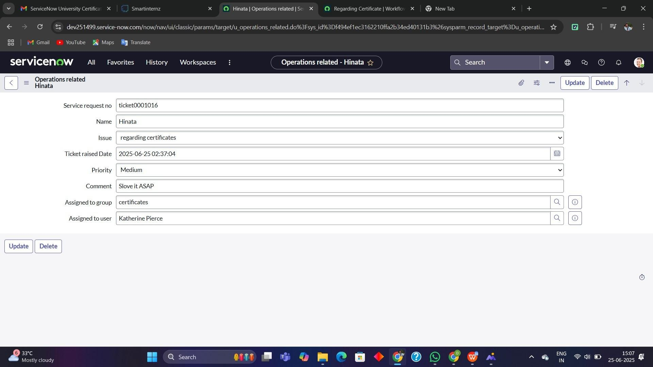

# Results:

* + All tickets assigned correctly based on issue
  + Unauthorized users restricted from modifying sensitive data
  + Groups receive only relevant tickets

# Conclusion:

This automation significantly improves the efficiency of ticket handling in ServiceNow. It ensures timely resolution by directing the tickets to appropriate groups based on predefined criteria. The use of Flow Designer and ACLs offers a secure and scalable foundation for managing enterprise- level support systems.